26 Q1 Mediexpense Manual Penetration Test

Introduction:

As part of the security assessment, a comprehensive manual penetration test was conducted to evaluate the web application against the OWASP Top 10 risk categories. The objective of this assessment was to identify security weaknesses arising from improper input handling, broken access controls, authentication and session management flaws, insecure design decisions, misconfigurations, vulnerable components, and weaknesses in business logic enforcement.
Testing focused on all critical application trust boundaries, including client–server interactions, authentication and authorization workflows, session management, data processing endpoints, and integrations with external services. Each area was reviewed to assess the effectiveness of implemented security controls, validate assumptions made in the application design, and identify conditions that could lead to exploitation under real-world attack scenarios.
The assessment included manual inspection of application behavior combined with targeted request manipulation to evaluate susceptibility to common attacks such as injection, cross-site scripting (XSS), cross-site request forgery (CSRF), insecure direct object references (IDOR), authentication and authorization bypass, sensitive data exposure, and logic abuse. Particular attention was paid to parameter integrity, enforcement of server-side validation, proper handling of user-controlled inputs, session and token lifecycle management, and the consistency of security checks across all application states.
Testing was performed in a controlled test environment using an authenticated, gray-box approach. The goal was to validate the robustness of the application’s security posture against realistic attacker techniques, ensuring alignment with OWASP Top 10 security best practices and resilience against common web application attack vectors.

Table of Contents
Introduction: 2
26Q1 Medi Zalaris Dev Manual Audit 4

26Q1 Medi Zalaris Dev Manual Audit
Description
The application is manually tested for any security vulnerabilities

File Upload Test Create expense - manually

Refer screenshot atatched below for the page under test

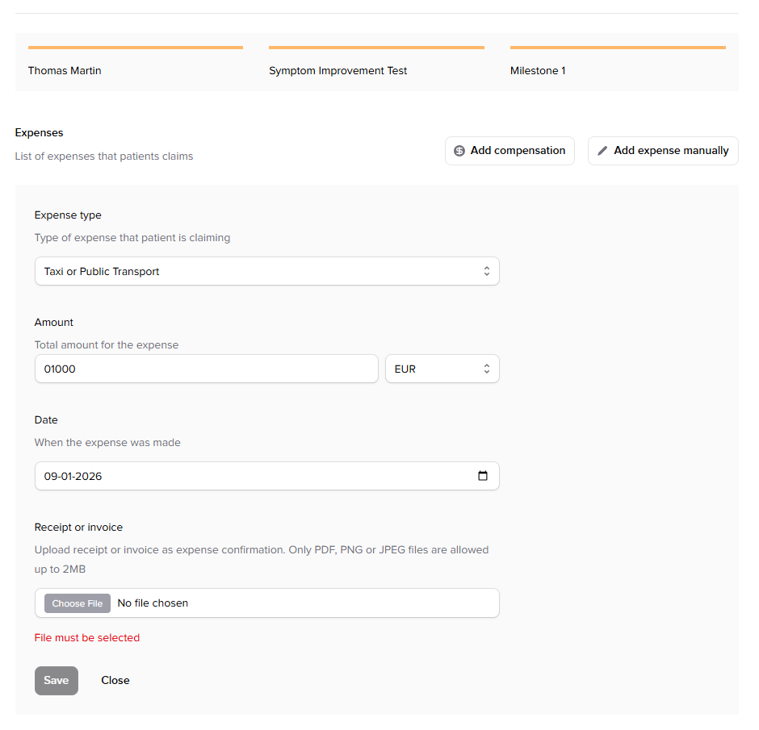

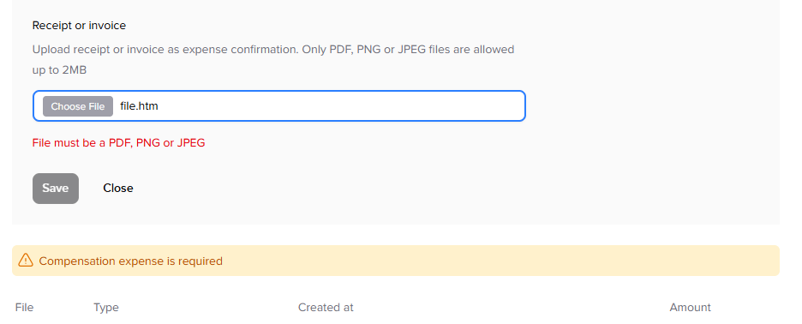

Upload the HTML file to the application

The application detects the file and rejects it

No capture the file upload request and alter the file format , content-type and file content

The request is accepted by the server and application

Refer Screenshot atatched below for evidence

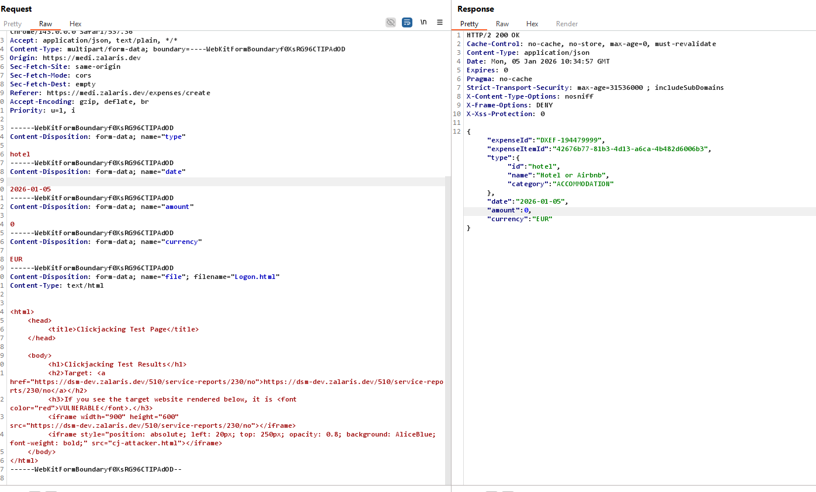

The application accepts the HTML file and is uploaded to the

Refer screenshot attached below for evidence

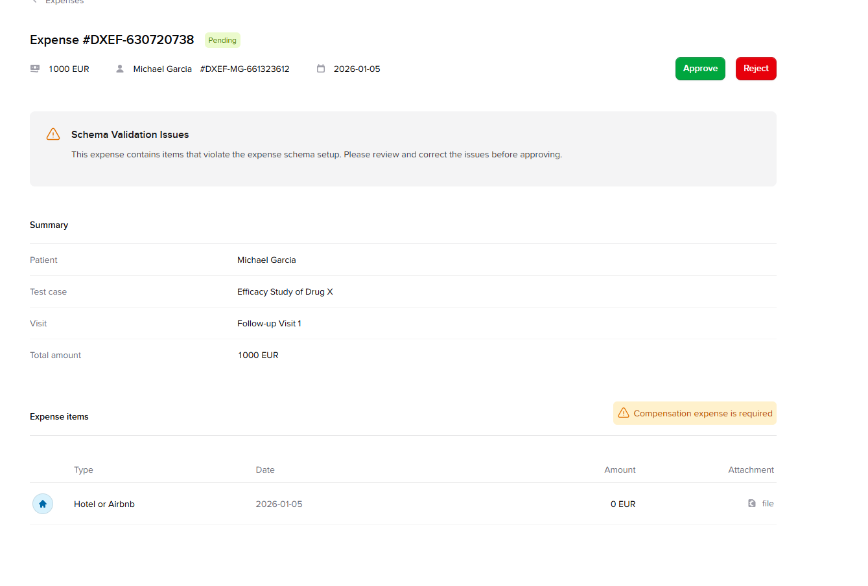

The application also accepts the exe file - refer screenshot attached below for evidence

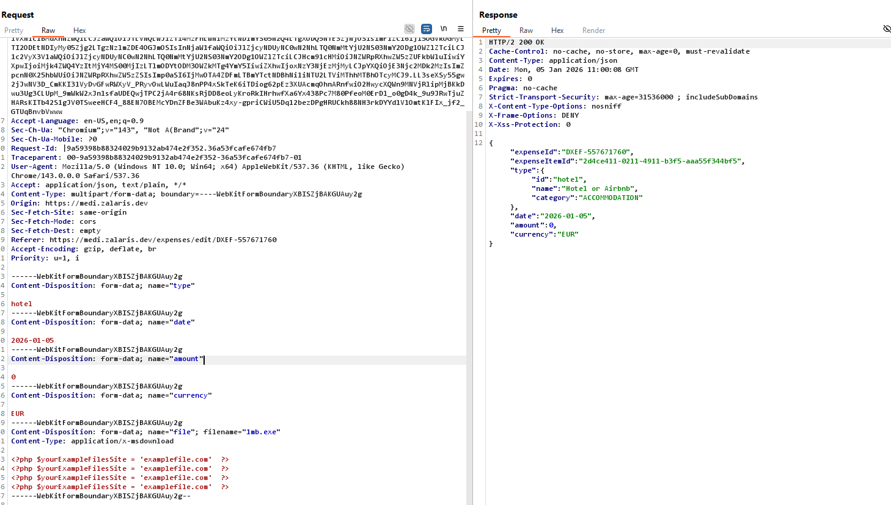

Possible DoS when parameter is tampered

Access the expense list for the application

Capture the request

Refer screenshot attached below for reference

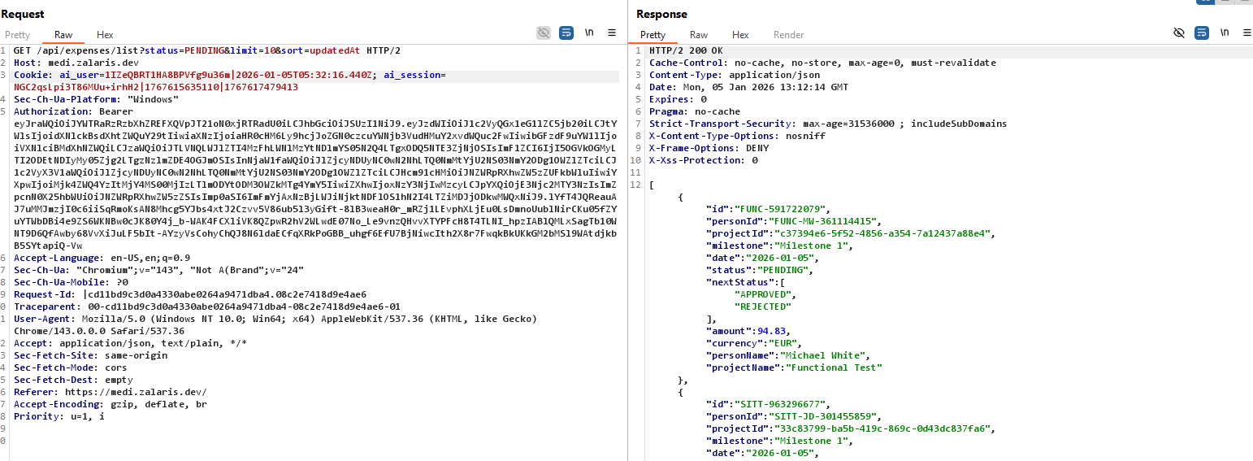

Alter the limit parameter from 10 to -1 and forward the request
The server responds with 503 service unavailable

Refer Screenshot attached below for evidence

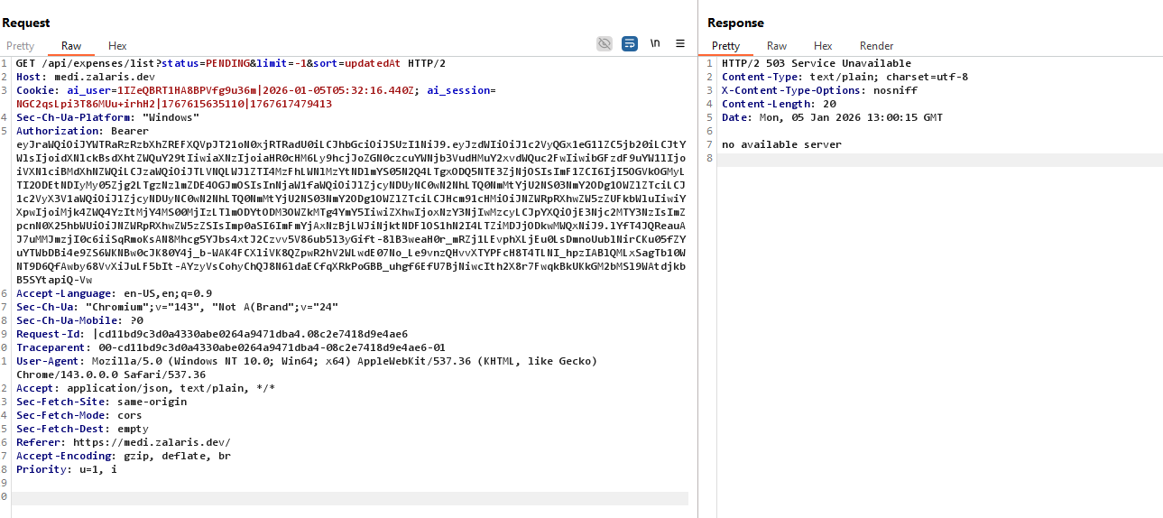

Generate a number list for from 1 to 50 once forward the request to Intruder start the attack

The server responds with 503 service unavailable

Re-Load the application https://medi.zalaris.dev

The application faces latency in loading and received 503 service unavailable error

Refer screenhot attached below for evidence

